# Bhojan

## Introduction to the application

Bhojan is an Android application that is built for people who are interested in cooking, from seasoned chef to those who are just starting out in kitchen. Overall, it help users to discover various recipes, create and save different food recipes. Overall, it helps to make cooking a delightful experience. The key features of the app and along with the screenshot of the application are as follows.

**1. Login & Signup:**

The following screenshot displays the login page of the Bhojan app. By using this form, the users can log in using their existing credentials and new users can sign up using google or create a new account. Firebase has been used for storing the user credentials.

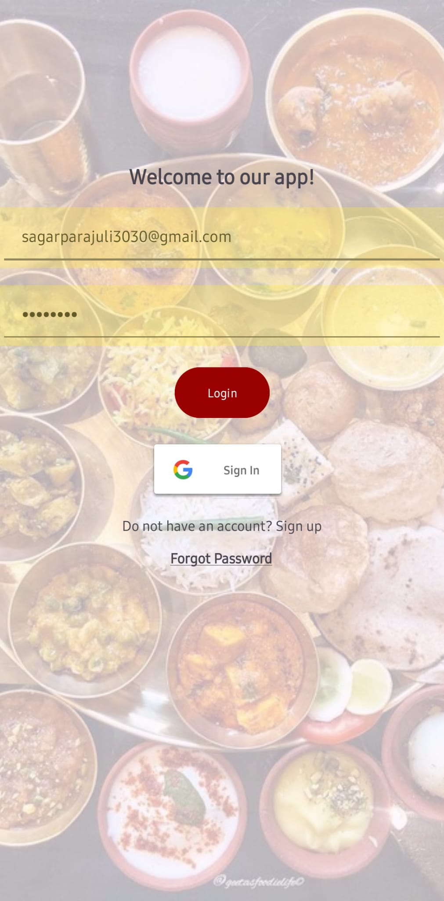

**2. User Authentication:**

Registered users within the app has the ability to use the password that has been stored already. If the user enters incorrect password or email address, he/she cannot access the system. Therefore, for security purpose the authentication has been set using Firebase Authentication that includes secure password storage and encryption to protect user data.

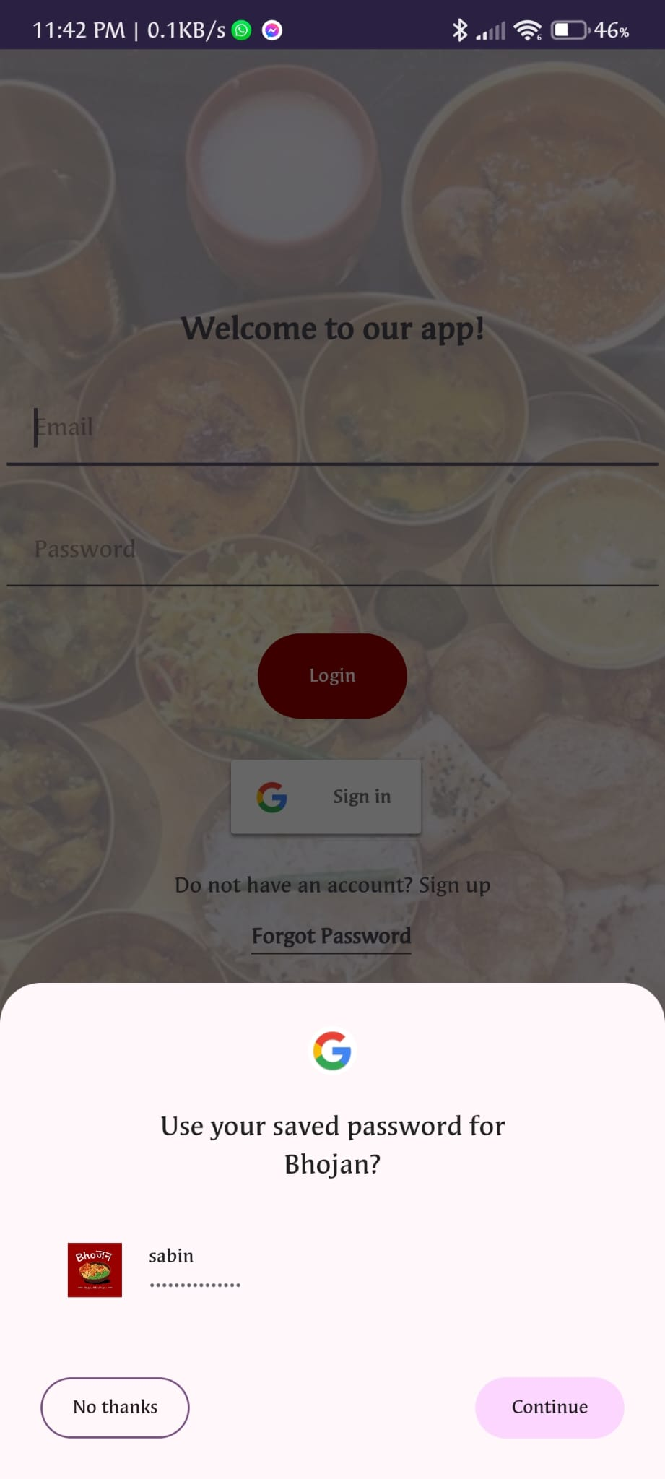

**3. Forgot Password:**

****In case user forget their password, the app provides a "Forgot Password" feature. After enter their email address, they get the verification directly to their email. This allows users to reset their password securely through a verification process, ensuring they can get access to their account without any trouble.

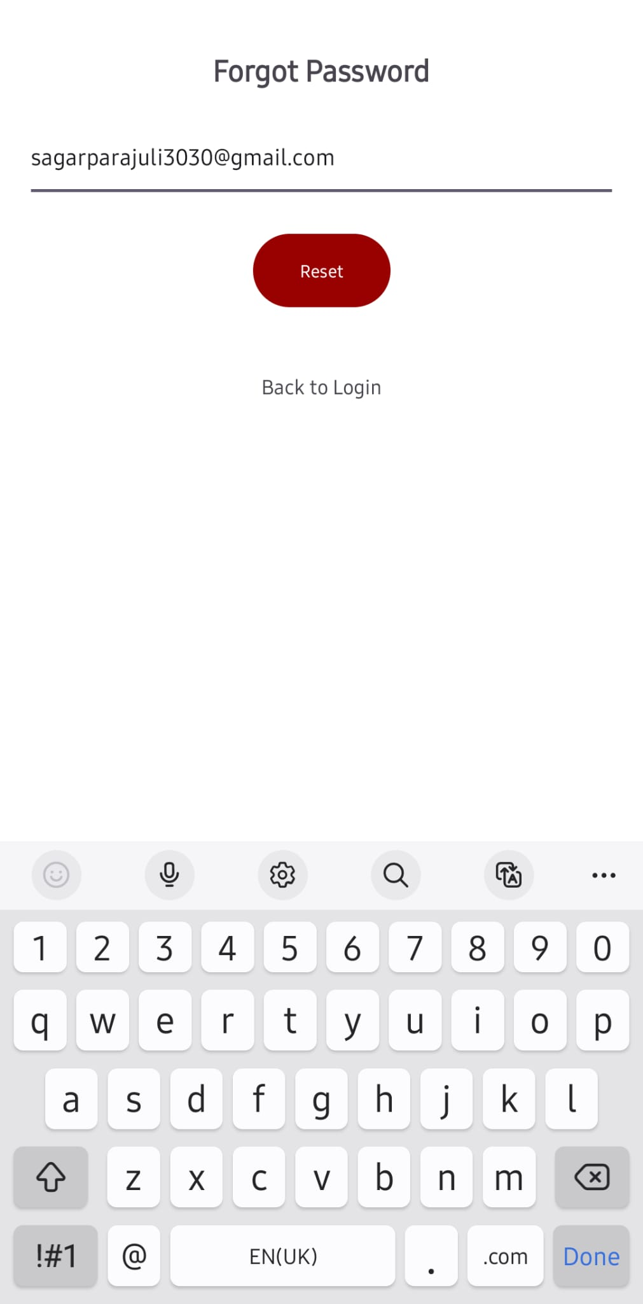

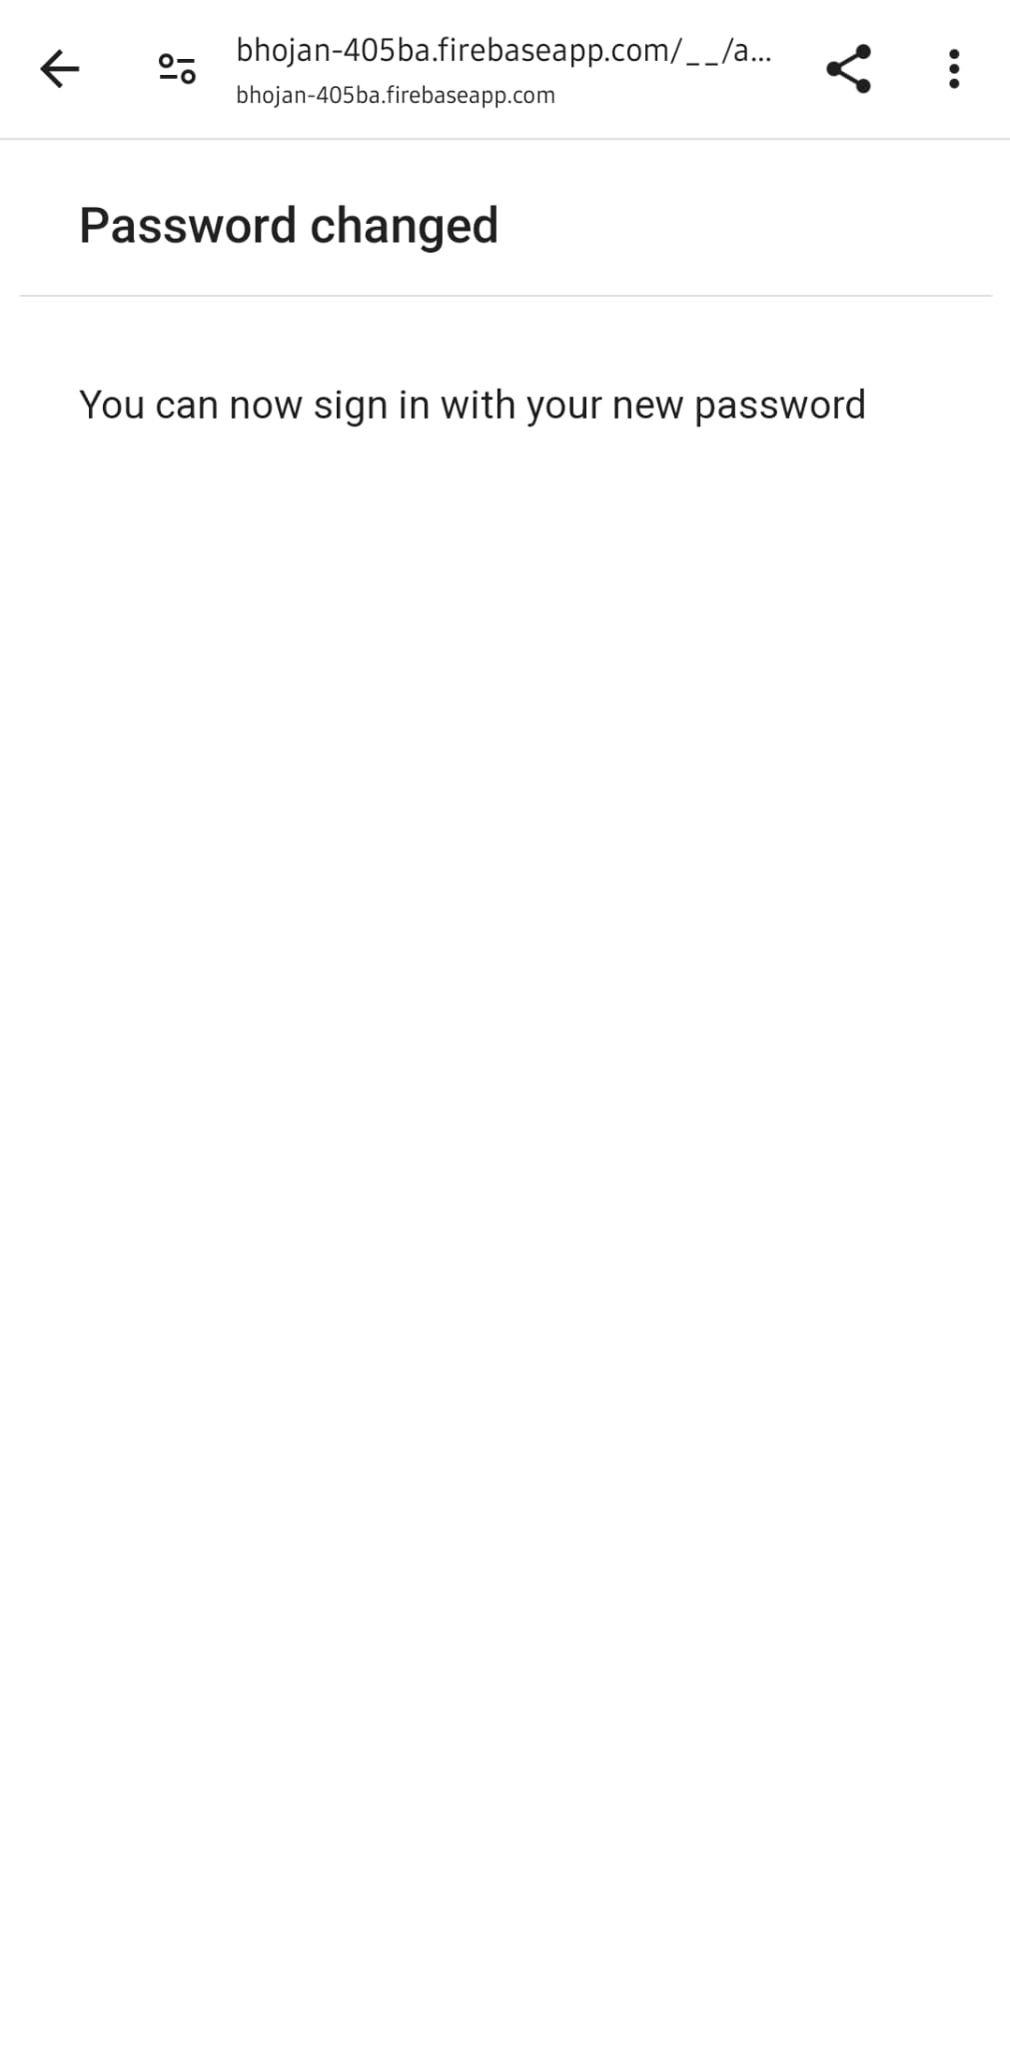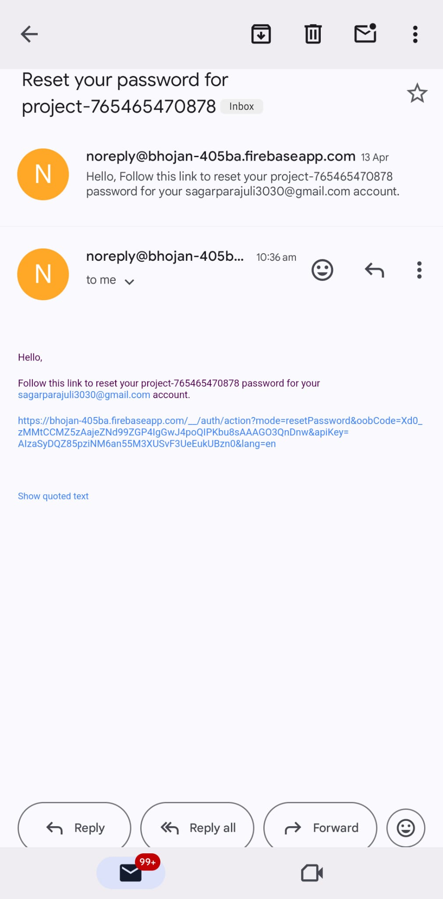

**4. Menu:**

The Menu feature is where users can explore a variety of recipes. Users can search and browse through variety of different dishes such as; indian cuisine, sushi, momo and many more using the search bar on the top. Moreover, users can also switch from light mode to dark and vice versa. For the personalized experience, users can see their name on the center and navigate through different pages using the bottom navigation such as; home, add and my profile.

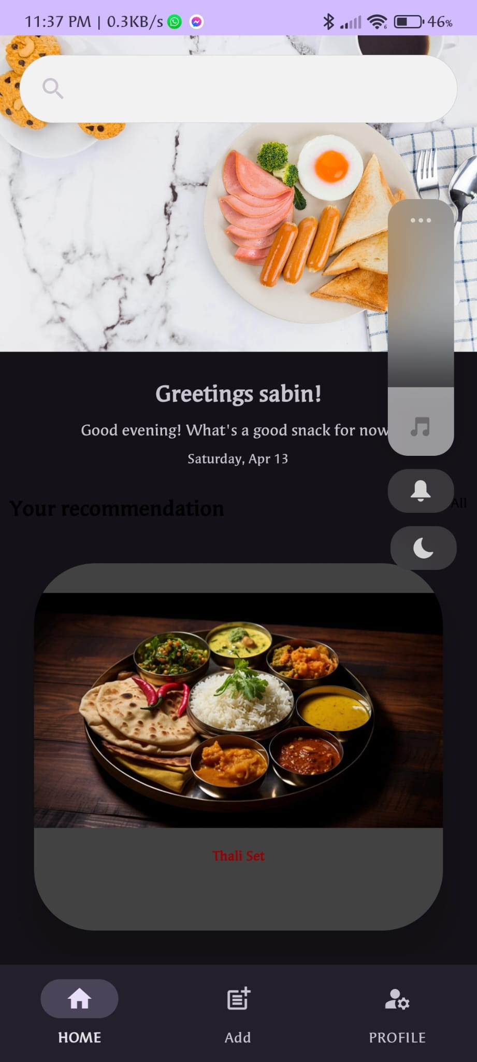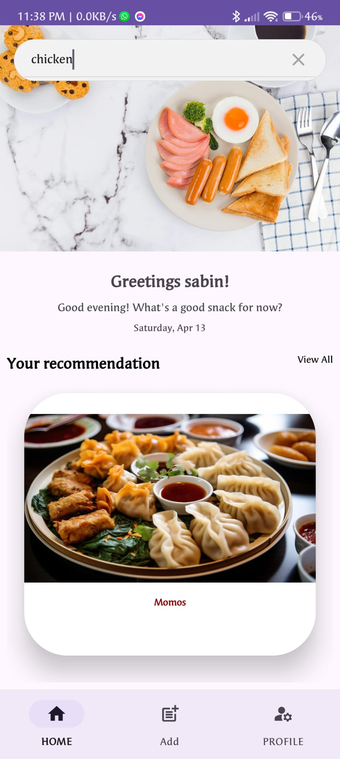

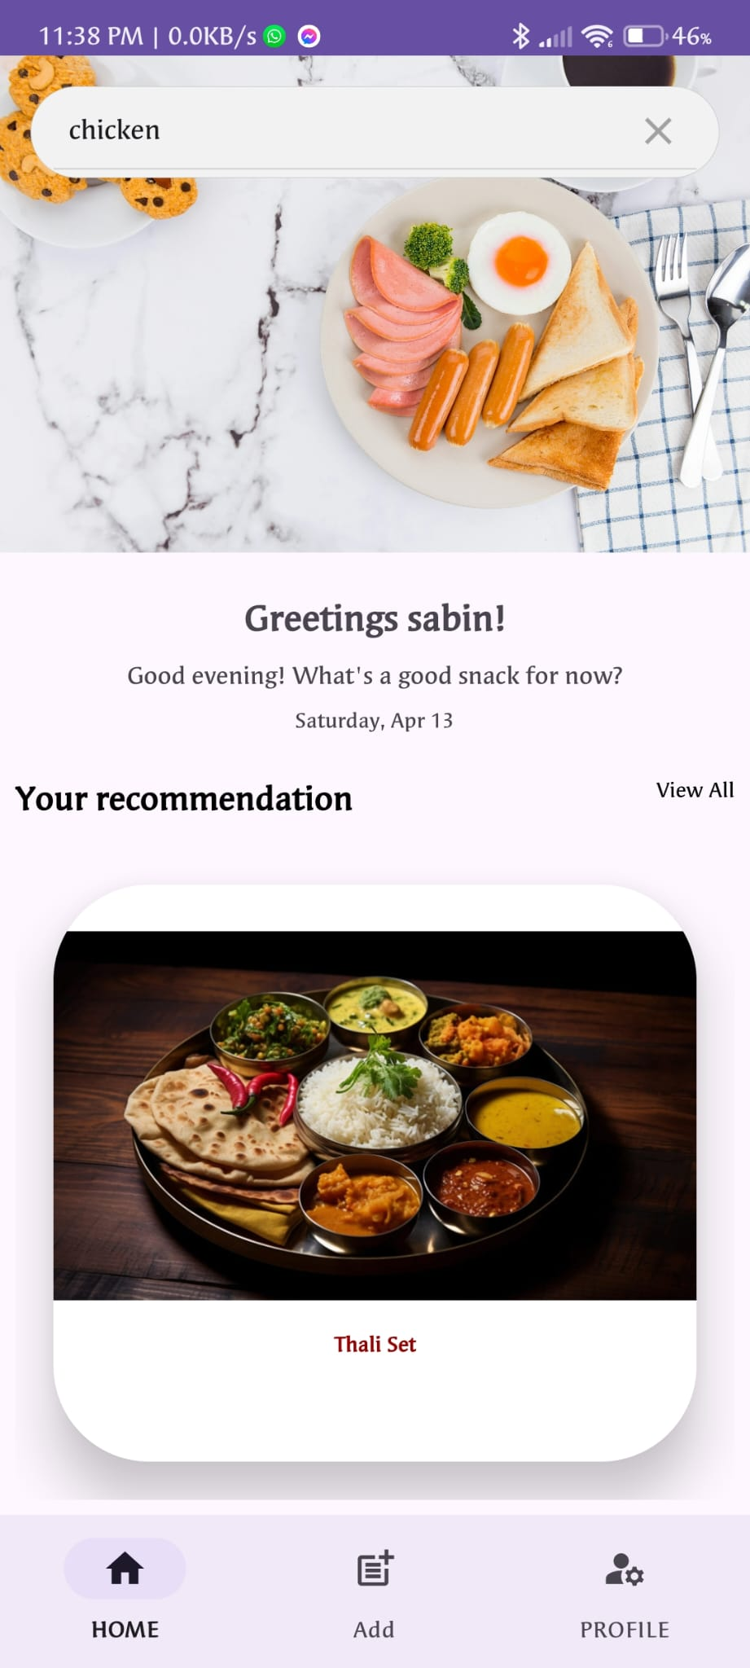

**5. Create/Add And Delete Recipes:**

One of the core functionalities of the app is the ability for users to contribute their own recipes. Users can easily create and add or delete new recipes to the app's database. This includes uploading a photo, listing ingredients, providing step-by-step instructions to prepare the meal.

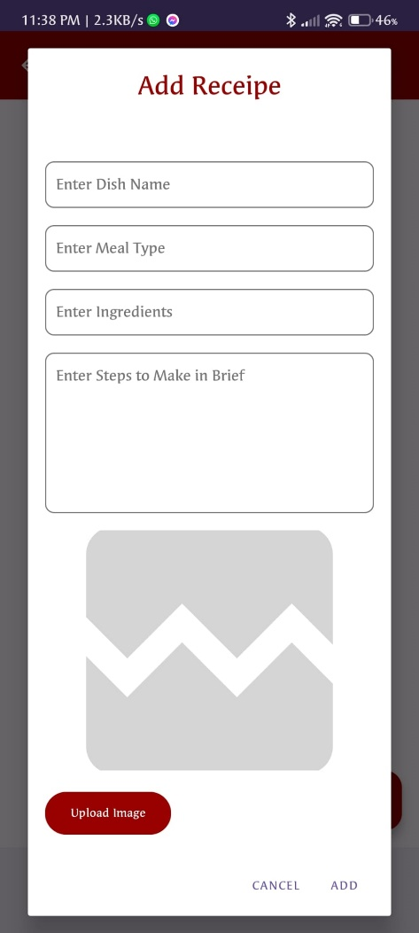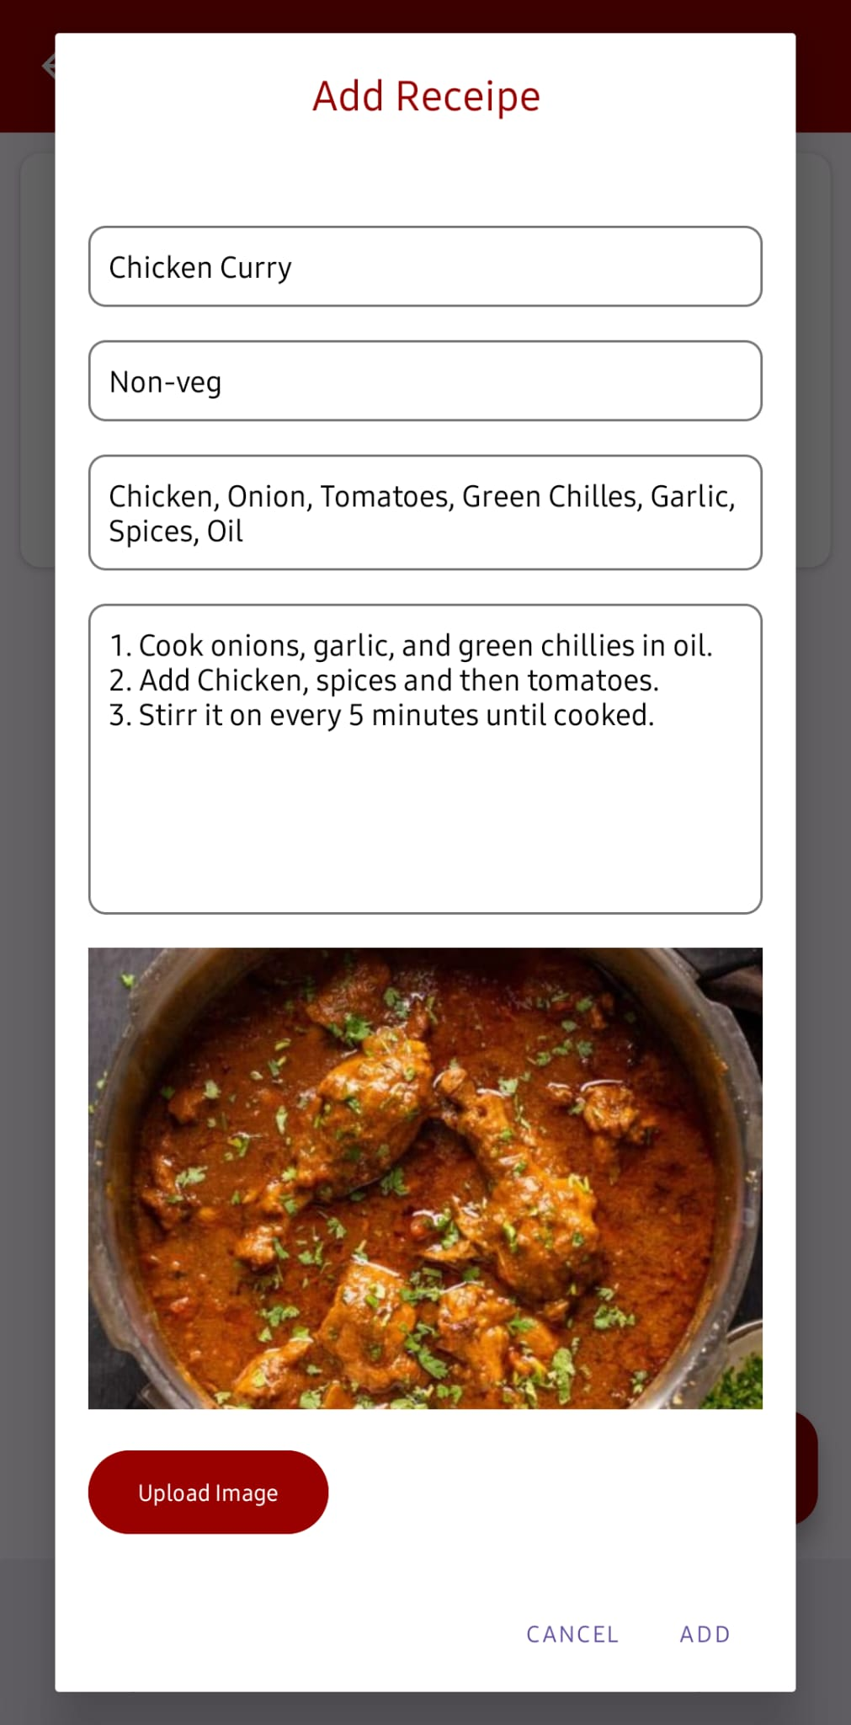

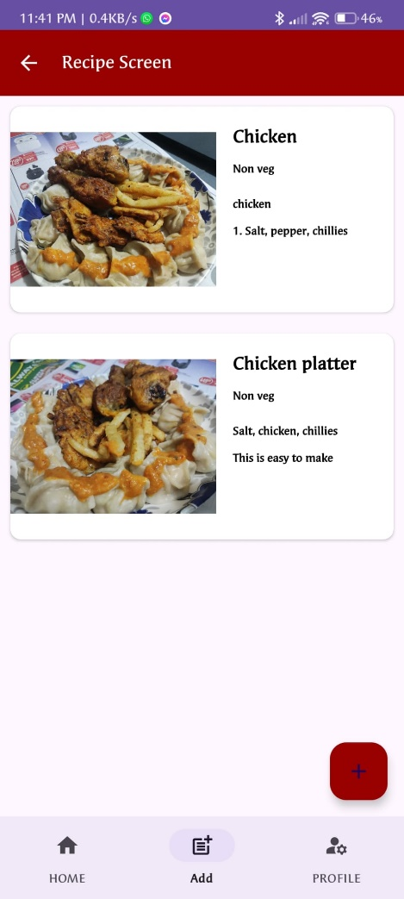

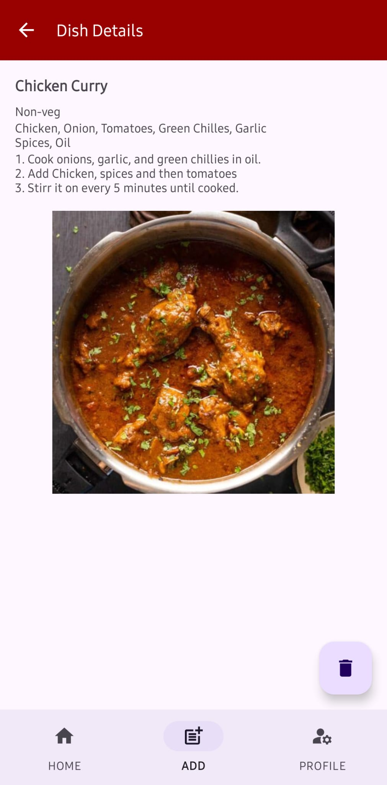

**6. Language Change:**

The users can the application in two different languages; English and French.

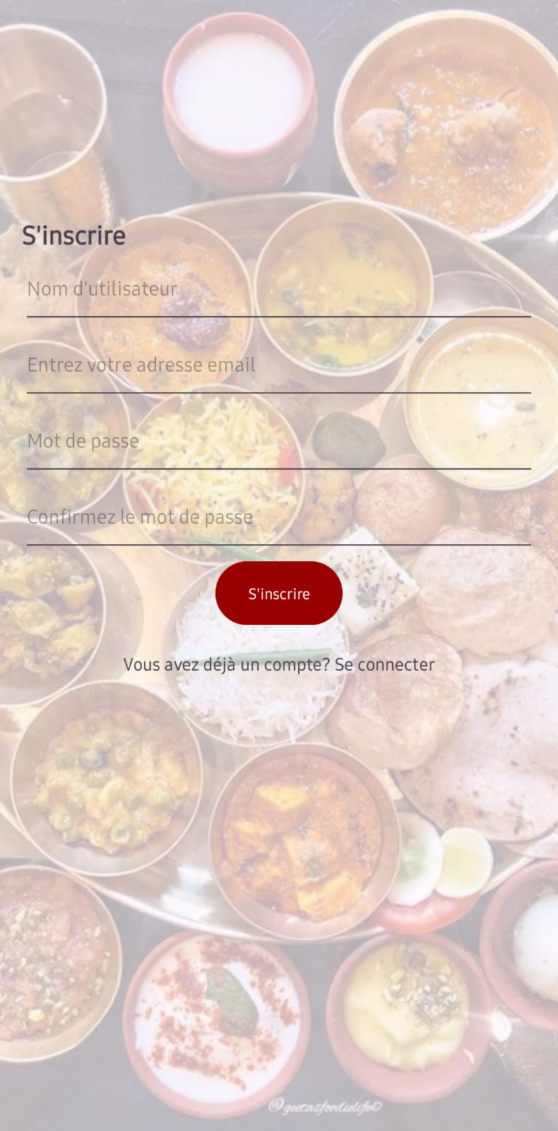

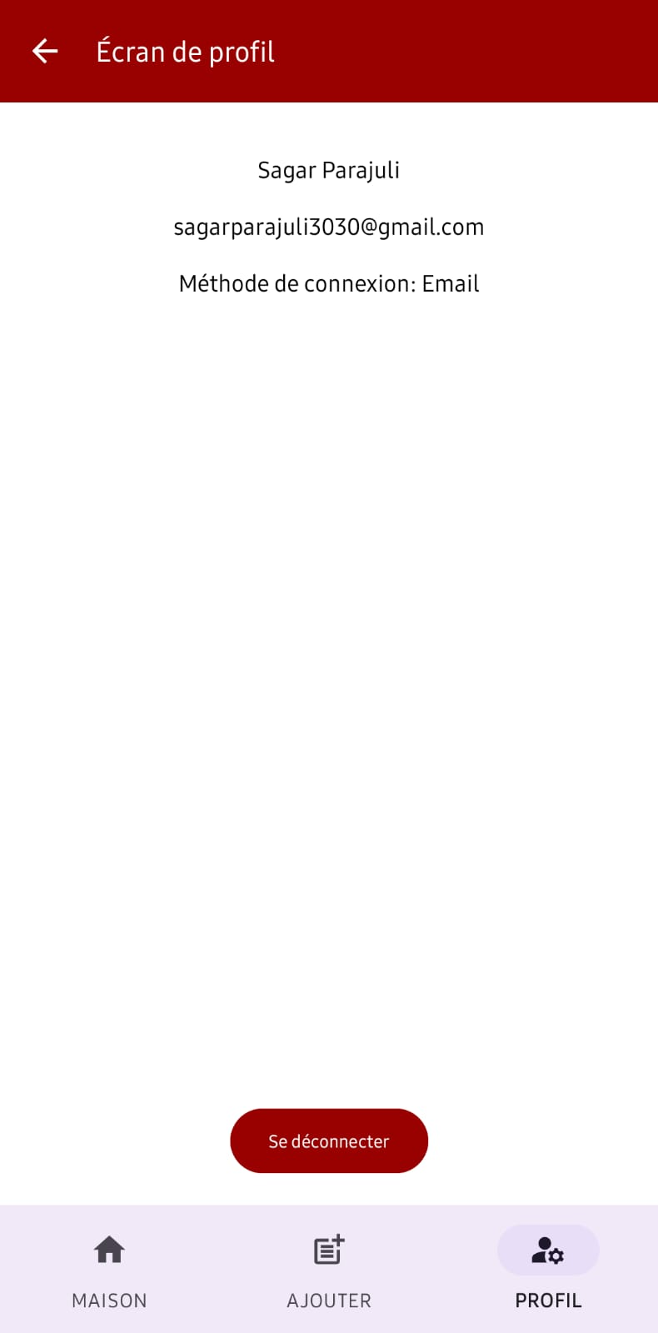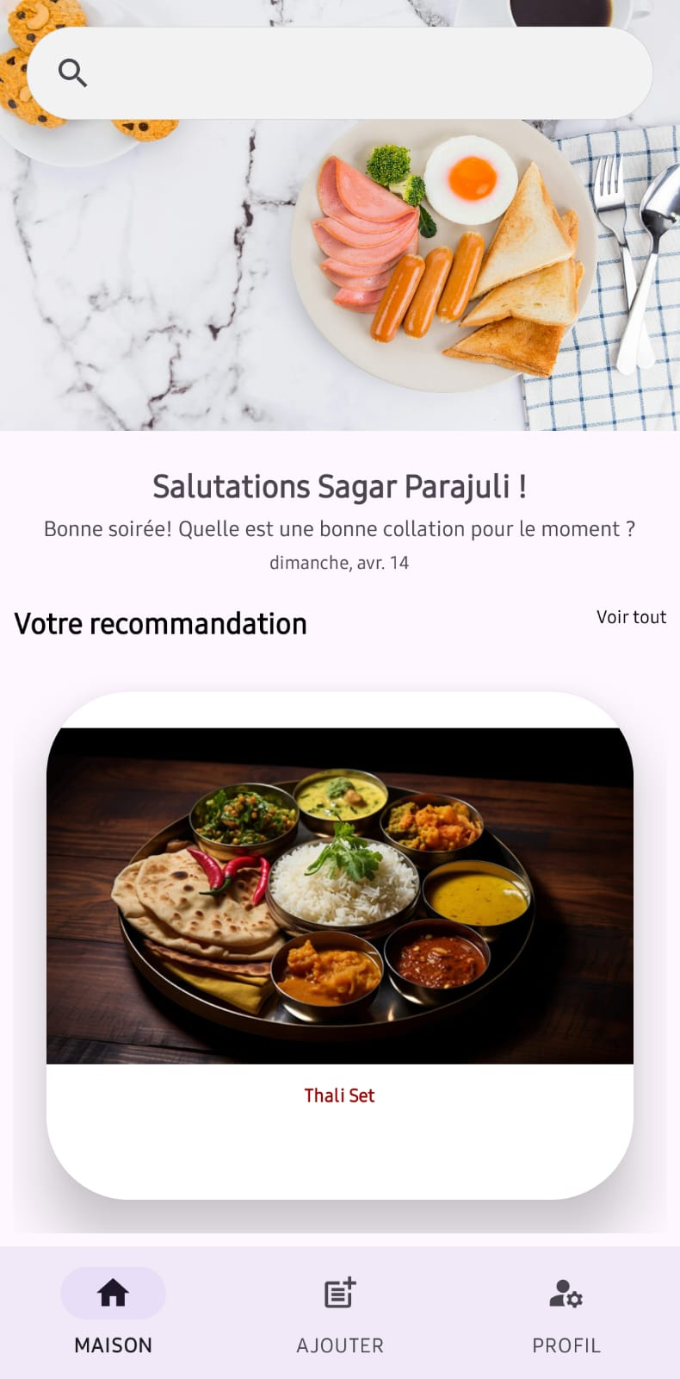

**7. User Profile and Logout:**

The users can use the profile tab to view their information along with their name, email address and the login method they has used. This helps to build a personalized experience to the user while they are using the application. Finally, the users can also logout from the application as per their wish

